Explainable Diabetic Retinopathy Severity Detection
https://github.com/calebburtonuncc/biomedFinal

Caleb Burton
ECGR 4116
Final Project Report

  - Introduction
Diabetic retinopathy (DR) is a diabetes-related condition on a patient’s eye; specifically, the retina. Long-term diabetes allows for irregular blood sugar levels to affect fragile vessels that line the retina. If these blood vessels leak, grow abnormally, or even well, vision loss is introduced.
Optometrists and ophthalmologists use specialized machines to take still images of the retina. These retinal images may contain visual signs of DR including hemorrhages, abnormal growth, and other signifiers. This makes these fundus (retinal area) images useful in classification in DR diagnoses.
The goal of this project is to train a machine learning model to classify these fundus images to predict the severity of a diabetic retinopathy diagnosis. Beyond this initial prediction, the model will have enough understanding of the image that attention sensitive information will be available for explanation.
The dataset that was used was The APTOS 2019 Blindness Detection dataset. This package includes 3,662 fundus images and CSV files that classify each image into 5 different DR intensities. These classifications include ‘No DR’ - ‘Mild’ – ‘Moderate’ – ‘Severe’ – ‘proliferative DR’.

  - Methods and Materials
The dataset was stored in a Google Drive cloud storage platform. Google Colab was used to as the main compilation device to easily access the cloud-stored data. Throughout compilation, checkpoints of weight progress were stored on the same drive to allow quit and resume functionality on a restricted runtime.
The notebook was trained and tested on premade splits that the dataset was delivered with. The train.csv and test.csv files mapped each image to its diagnosis. This includes 2,563 training images, 549 validation images, and 550 images. This comes to a rough split of 70% training, 15% validation, and 15% testing percentages.
  - Preprocessing
The data was imbalanced in having most images belonging to the ‘No DR’ classification. Custom weights were used to allow smaller classes to be properly weighed throughout the training process. Without this, the loss measurements on these smaller classes when compared to larger classes with more chances to experience loss.
Each image was processed before training to ensure consistency. The following process was applied to each image:
Step 1: open each image
Step 2: convert to RGB
Step 3: remove large black borders
Step 4: resize to 224x224 pixels
Step 5: save processed images to Drive
Step 6: use ResNet50 preprocessing before model input
Some of these changes were made to avoid attention wrongly placed on image borders, higher resolution images getting more pixel attention, and some were enacted to better implement with the ResNet50 transfer learning network. Images also met randomized augmentations to prevent overfitting and memorization. These augmentations include small rotations, zoom changes, horizontal flips, and mild brightness changes.
  - Model Architecture
Transfer learning was a technique used in this project. Machine vision weights were imported using the ResNet50 layers. The input is a 224x224 image passed into the ResNet50 network. Global average pooling was used along with ReLU. A dropout sweet spot was found at 0.30 (or 30% dropout) and 5 softmax units.
For training, the ResNet50 base layers were frozen, and the custom head was being made based on the fundamental weights using a training rate of 1_{E}-4. Stage 2 keeps some of ResNet frozen and the top 30 layers were able to be trained. While keeping the batch normalization layer frozen was done with a learning rate of 1_{E}-5. This second stage was used to fine tune the weights from the fundus images slowly building from the ResNet roots.
A crucial point during training within a cloud-based IDE, weights from each epoch were saved to the same Google Drive. This was needed since Colab would shut down the runtime after an hour or so of program runtime. This resets all local variables in the environment each runtime restart. However, when weights are saved, restarting the runtime will just loop back to the most previous epoch weight checkpoint.
  - Program Outputs
A set of evaluation methods were used on the test set’s results. Using weighted F1 score, weighted one-vs-rest AUC, a classification report, a confusion matrix, and ROC curves.
Grad-Cam is a premade python tool that creates a mask based on pixel attention weights from the evaluated image. This allows a user to see what part of an image the model used the most in making its classification decision. This takes away the black-boxiness of AI vision models. Helping in understanding logic leaps made in bad predictions and critical features in good results.
Occlusion Sensitivity is a technique that blocks patches of the images and reruns the prediction. The results are compared to the original confidence level. The patches that give the most confidence drop when that patch is dropped will be labeled as more important. The model uses this technique and masks the occlusion over the original image to see which portions were the most important to the decision.
The last portion in pursuit of the model’s explainability is the chat bot implemented. A Groq API key was used, fed variables and results from the test image on stage, and will understand questions about this image. The LLM will then produce answers based on information the model fed about the diagnosis, dataset, etc.
  - Results
This model was tested first with no fine-tuning and 80 epochs. Then compared with the improved model, only using 30 epochs in total. The first model will be referenced as the baseline model. The second model is the improved model. The improved model was tested on accuracy for classifying each class. A confusion matrix for each class can be seen in Appendix A below. The results were 93% accurate in finding ‘No DR’, 50% in ‘Mild’, 74% in ‘Moderate’, 41% in 'Severe’, 68% in 'Proliferative DR’. More details for the baseline and improved model can be seen appendix B.

  - Discussion
The first attempt at this model earlier in the semester was not very accurate due to the transferred weights not being fine-tuned, no matter how many epochs I ran over the course of multiple days, the baseline model was not accurate. The improved model is true to its name and easily classifies each image. While the 5-classes are less than 90% accurate on average, looking for a binary classifier, signaling DR or no-DR is extremely useful in this model. The explainability of this model gives great insight into each case and a broad scope for better doctor training. This model could possibly be implemented in a pre-screening process at a doctor’s office before the “chair timer” even starts, giving the doctor a head starts on where to look in the fundus image. Groq was easy to implement once Grad-Cam and occlusion sensitivity were enabled. This allows a more human-like and understandable interaction with predictions. There are examples of images that had unexpected Grad-Cam highlights on the image due to the 5-class classification nature of the project. This kind of result shows that the difference between mild and severe findings can lie in small details outside of obvious signs like hemorrhages and cotton spots.

  - Appendix
A: Model Confusion Matrix
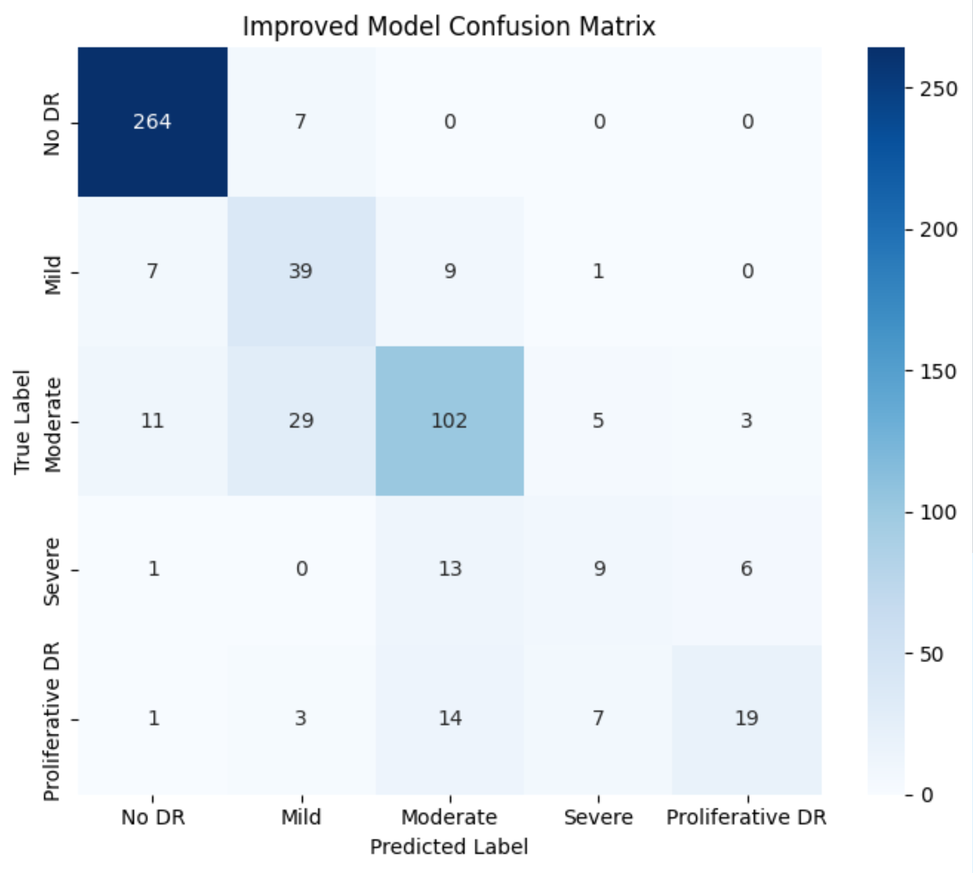
B: Accuracy Metrics
Item | Value
Baseline accuracy | 0.5055
Improved accuracy | 0.7873
Baseline weighted F1 | 0.4699
Improved weighted F1 | 0.7820
Baseline weighted AUC OvR | 0.8411
Improved weighted AUC OvR | 0.9486
Baseline Moderate recall | 0.0100
Improved Moderate recall | 0.6800
Baseline Proliferative DR recall | 0.0000
Improved Proliferative DR recall | 0.4318

Item | Value
No DR | Precision 0.9296, recall 0.9742, F1 0.9514, support 271
Mild | Precision 0.5000, recall 0.6964, F1 0.5821, support 56
Moderate | Precision 0.7391, recall 0.6800, F1 0.7083, support 150
Severe | Precision 0.4091, recall 0.3103, F1 0.3529, support 29
Proliferative DR | Precision 0.6786, recall 0.4318, F1 0.5278, support 44

  - References
Asia Pacific Tele-Ophthalmology Society. (2019). APTOS 2019 blindness detection [Data set]. Kaggle. Retrieved March 18, 2026, from https://www.kaggle.com/competitions/aptos2019-blindness-detection/data
Butt, M. M., Iskandar, D. N. F. A., Abdelhamid, S. E., Latif, G., & Alghazo, R. (2022). Diabetic retinopathy detection from fundus images of the eye using hybrid deep learning features. Diagnostics, 12(7), Article 1607. https://doi.org/10.3390/diagnostics12071607
grad-cam. (n.d.). [Computer software]. Python Package Index. Retrieved April 3, 2026, from https://pypi.org/project/grad-cam/
He, L., Wang, S., Chen, C., Wang, Y., Fan, Q., Chu, C., Fan, L., & Xu, J. (2025). Network occlusion sensitivity analysis identifies regional contributions to brain age prediction. Human Brain Mapping, 46(8), Article e70239. https://doi.org/10.1002/hbm.70239
Lin, A. (2025). Efficient fusion transformer model for accurate classification of eye diseases. Scientific Reports, 15, Article 36223. https://doi.org/10.1038/s41598-025- 20226-z

